**Project Name: Tourist Inn Booking System**

**Project Members:**

**Akshay Surwase 210943120011**

**Yuvraj Gajbhare 210943120117**

**Mrunal Gaurkar 210943120056**

**Priyanka Patil 210943120064**

**Abstract:**

As a tourist we often visit remote places where due to lack of development, hotels are not available and if available room bookings are super-expensive that everyone cannot afford it. This project provides a platform to those house owners who can provide their budget friendly guestrooms to the tourists. Tourists are provided with an ease to explore sightseeing at the nearby locations.

This project deals with developing an website for Online Rooms Booking system. It provides the user with a catalogue of different category of Houses . In order to facilitate Booking user Registration is done and registering a house owner Registeration is done. The system is implemented using a 3-tier approach, with a backend database, a middle tier of Express And Node , and web browser as the front end client.

In order to develop an Booking website, a number of Technologies must be studied and understood. These include multi-tiered architecture, server and client side scripting techniques, implementation technologies such as MERN

This is a project with the objective to develop a basic website where a consumer is provided with a Houses he can Book. Where the user will be given the power to Browse between different options and book and would be able to review it. And owner with uploading his details and provide service as per the feedBack

**Implementation Technologies:**

1. **NodeJS:**

# NodeJS is primarily developed in JavaScript, CoffeeScript, and C++. NodeJS is an asynchronous, event-driven JavaScript runtime environment that can run JavaScript code outside the web browser. NodeJS is built on JavaScript, so it is extremely lightweight and unbelievably efficient.

# NodeJS is a perfect choice when your application requires to deal with complex and intensive data processing. NodeJS can process complex data with ease and that’s why a lot of apps that require intensive data processing use NodeJS. That’s why people hire NodeJS Developers to build their apps.

**Features of NodeJS:**

# As NodeJS is a runtime environment of JavaScript, NodeJS applications are lightweight and faster as compared to the traditional applications that take a lot of time to load and process data. So, it is a JavaScript boon that your applications are lightweight and lightning-fast in processing the data.

# When your application requires efficient I/O tasks, you can choose NodeJS without giving it a second thought. NodeJS Applications are a great fit when your applications process a lot of Input and Output tasks. For example, an application that takes frequent inputs from the users.

# NodeJS applications consume much lower memory than traditional mobile apps. When your app is built with NodeJS, you can save a lot of memory on your device as NodeJS applications can run even in memory shortage, so it won’t be hard for your device to run the applications built with NodeJS.

# Another big advantage of choosing NodeJS is its Node Package Manager, also known as the NPM. The Node Package Manager is constantly growing and more and more features are being available with the constantly growing Node Package Manager. You can’t deny the fact that the NPM is one big reason to choose NodeJS development for your next business application

1. **ReactJS**

React JS is basically a JavaScript library built and maintained by Facebook. According to the creator of React JS, Jordan Walke, React is an efficient, declarative, and flexible open-source JavaScript library for building simple, fast, and scalable frontends of web applications.

### **Speed**

The React basically allows developers to utilize individual parts of their application on both client-side and the server-side, which ultimately boosts the speed of the development process

### **Flexibility**

Compared to other frontend frameworks, the React code is easier to maintain and is flexible due to its modular structure. This flexibility, in turn, saves huge amount of time and cost to businesses.

### **Flexibility**

Compared to other frontend frameworks, the React code is easier to maintain and is flexible due to its modular structure. This flexibility, in turn, saves huge amount of time and cost to businesses

### **Performance**

React JS was designed to provide high performance in mind. The core of the framework offers a virtual DOM program and server-side rendering, which makes complex apps run extremely fast.

### **Reusable Components**

ne of the main benefits of using React JS is its potential to reuse components. It saves time for developers as they don’t have to write various codes for the same features. Furthermore, if any changes are made in any particular part, it will not affect other parts of the application.

3.0 **MongoDB**

As a definition, MongoDB is an open-source database that uses a document-oriented data model and a non-structured query language. It is one of the most powerful NoSQl systems and databases around, today.

Being a NoSQL tool means that it does not use the usual rows and columns that you so much associate with relational database management. It is an architecture that is built on collections and documents. The basic unit of data in this database consists of a set of key-value pairs. It allows documents to have different fields and structures. This database uses a document storage format called BSON which is a binary style of JSON documents.

**Features of MongoDB:**

**Schema-less Database:**It is the great feature provided by the MongoDB. A Schema-less database means one collection can hold different types of documents in it. Or in other words, in the MongoDB database, a single collection can hold multiple documents and these documents may consist of the different numbers of fields, content, and size. It is not necessary that the one document is similar to another document like in the relational databases. Due to this cool feature, MongoDB provides great flexibility to databases.

**Document Oriented:**In MongoDB, all the data stored in the documents instead of tables like in RDBMS. In these documents, the data is stored in fields(key-value pair) instead of rows and columns which make the data much more flexible in comparison to RDBMS. And each document contains its unique object id.

**Indexing:**In MongoDB database, every field in the documents is indexed with primary and secondary indices this makes easier and takes less time to get or search data from the pool of the data. If the data is not indexed, then database search each document with the specified query which takes lots of time and not so efficient.

**Scalability:**MongoDB provides horizontal scalability with the help of sharding. Sharding means to distribute data on multiple servers, here a large amount of data is partitioned into data chunks using the shard key, and these data chunks are evenly distributed across shards that reside across many physical servers. It will also add new machines to a running database.

**Replication:**MongoDB provides high availability and redundancy with the help of replication, it creates multiple copies of the data and sends these copies to a different server so that if one server fails, then the data is retrieved from another server.

**Aggregation:**It allows to perform operations on the grouped data and get a single result or computed result. It is similar to the SQL GROUPBY clause. It provides three different aggregations i.e, aggregation pipeline, map-reduce function, and single-purpose aggregation methods

**High Performance:**The performance of MongoDB is very high and data persistence as compared to another database due to its features like scalability, indexing, replication, etc.

**Advantages of MongoDB**

MongoDB is very flexible and adaptable to real business world situations and requirements.

* Queries can be made to return certain fields within documents.
* MongoDB supports field, range-based query, regular expression, etc. for searching the data from the stored data.
* MongoDB is a very easy DBMS system that can easily scale up or down.
* MongoDB helps you to uses internal memory for storing the working temporary datasets for which it is much faster.
* MongoDB offers primary and secondary indexes on any field.
* MongoDB supports the replication of the database.
* You can use MongoDB as a file storage system which is known as a GridFS.
* MongoDB offers various methods to perform aggregation operations on the data like aggregation pipeline, map-reduce or single objective aggregation commands.
* MongoDB allows you to store any type of file which can be any size without effecting our stack
* MongoDB basically uses JavaScript objects in place of the procedure.
* MongoDB supports special collection type like TTL (Time-To-Live) for data storage which will expire at a certain time
* The dynamic database schema used in MongoDB is called the JSON
* Indexes can be created to improve the performance of searches within MongoDB. Any field in a MongoDB document can be indexed.
* Replication – MongoDB can provide high availability with replica sets
* MongoDB can run over multiple servers, balancing the load and/or duplicating data to keep the system up and running in case of hardware failure.

1. **Hardware and Software Requirements (Minimum):**

**Hardware:**

1. Intel i3 processor 3rd generation or later / AMD Ryzen 200 2nd generation or later

2. 4 GB ddr3 ram.

3. Windows 7 Home edition or later.

4. 200 GB Sata HDD Space

5. Data Connection 200 kbps

**Software:**

1. VSCode
2. MongoDB Compass
3. ReactJS
4. NodeJS
5. Google Chrome Browser

**ER Diagram**

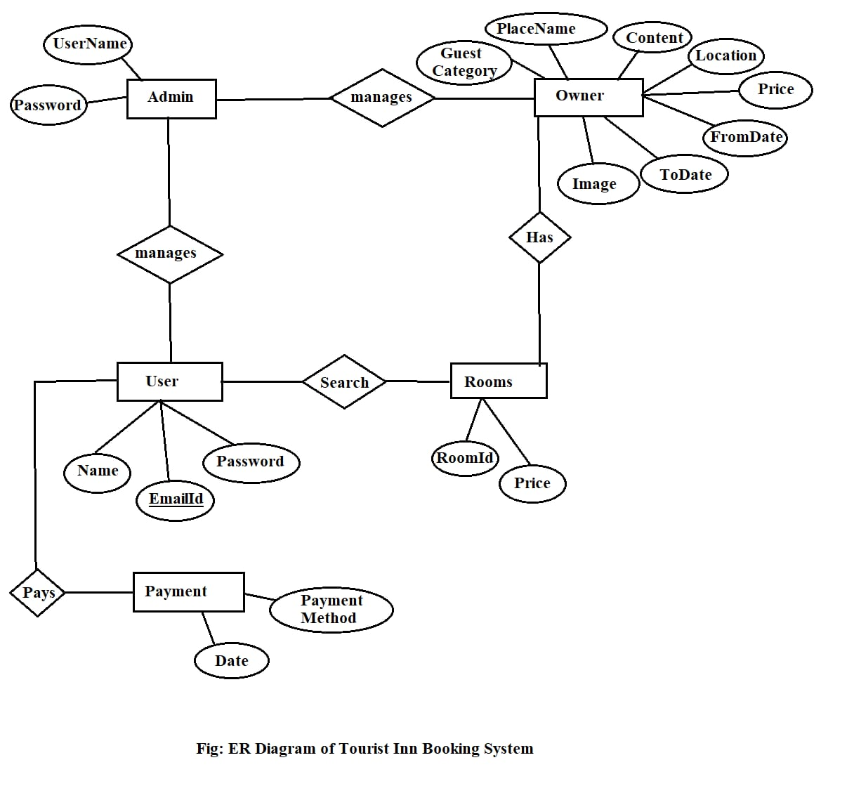

**Data Flow Diagram**

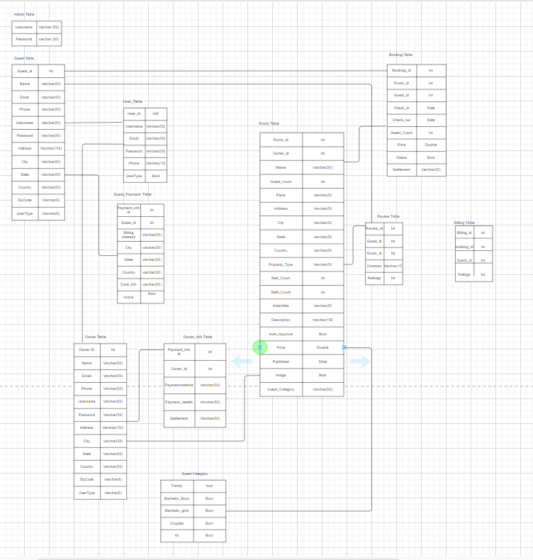

**Screenshots**



**End to End Flow of Application:**

**User:**

* 1. User will login to the portal or will have to register if he is not a registered user.
  2. After registration User will login and Dashboard page will be displayed to him which will display the previous Bookings and its status if any.
  3. From that page can User can Browse The different Listed Properties
  4. User will be able to Book the Rooms and he will be able to see his Bookings In The DashBoard

**Owner:**

1. Owner will login to the portal or will have to register if he is not a registered user and after Will have to register his property.
2. After registration owner will login and Dashboard page will be displayed to him which will display His property details.
3. The Bookings He has received will also be displayed in Dashboard along with the details of the user who has booked.
4. **Future Scope of Project**

In Future we can add the facility of Room Sharing Between Guests.

**Thank You!**